Test Case: tc008_SPX_Dev5_Validacion_Boton_Remove_Administrador_Menu
Step 1 - Enter username and password and click to button Enter : Credentials Entered
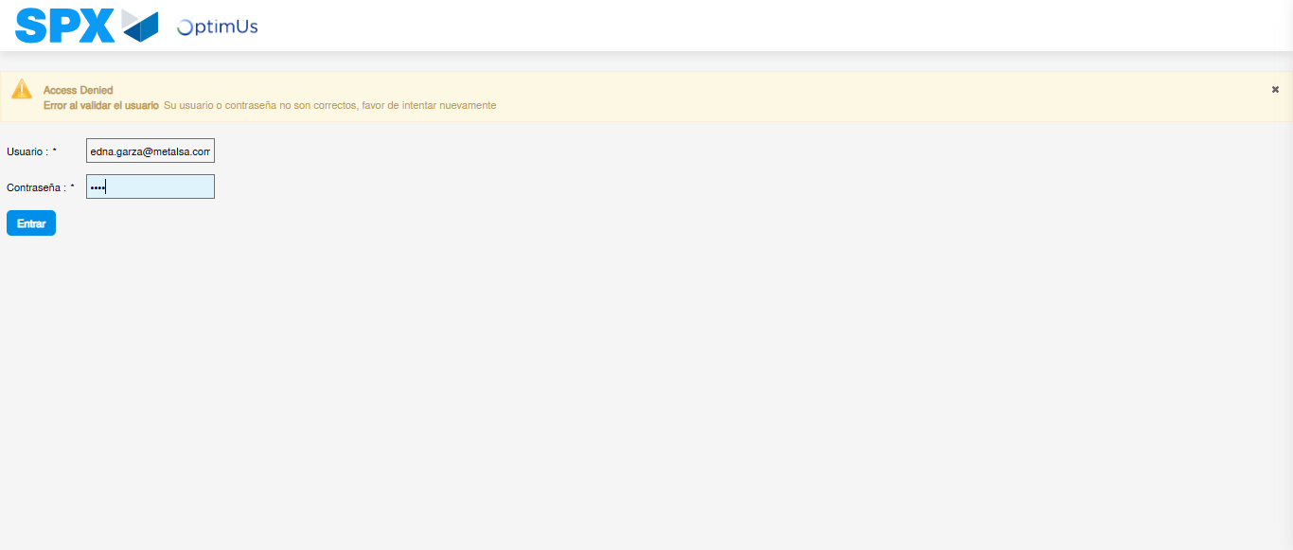Image file-name: QC_Testing-runTestMultipleTimes-nov. 20 2025, 01 53 35 p. m.

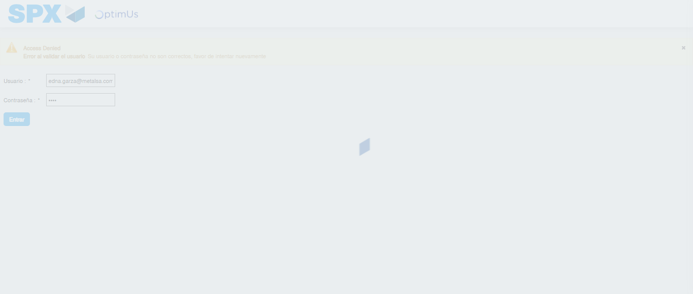Image file-name: QC_Testing-runTestMultipleTimes-nov. 20 2025, 01 53 36 p. m.

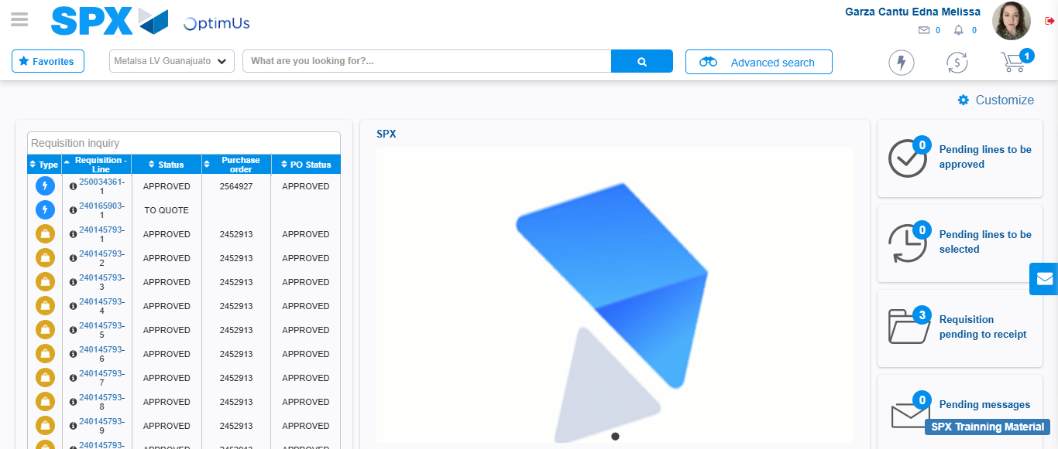Image file-name: QC_Testing-tc001_SPX_Dev5_Validar_Filtro_Campo_MenuName_Administrador_Roles_Menu-nov. 20 2025, 01 54 18 p. m.

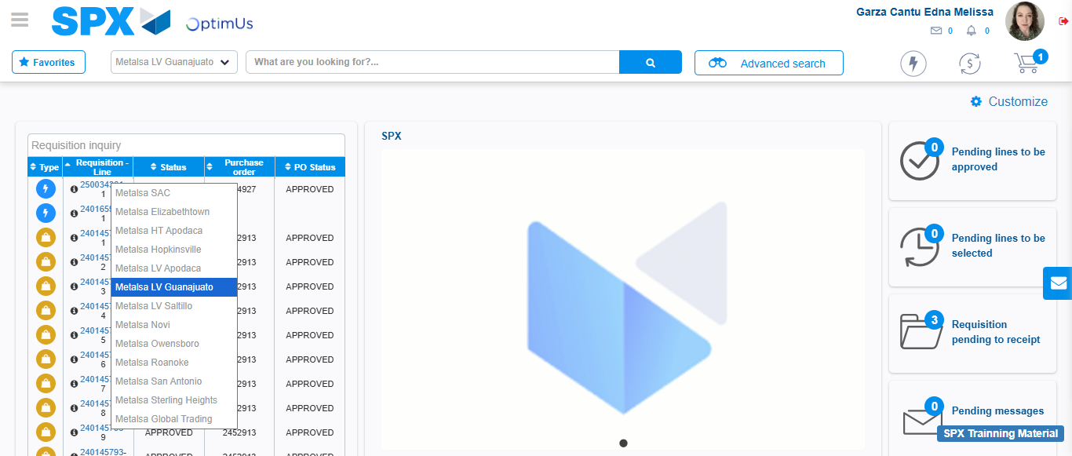Image file-name: QC_Testing-tc002_SPX_Dev5_Validar_Filtro_Campo_URLPath_Administrador_Roles_Menu-nov. 20 2025, 01 54 42 p. m.

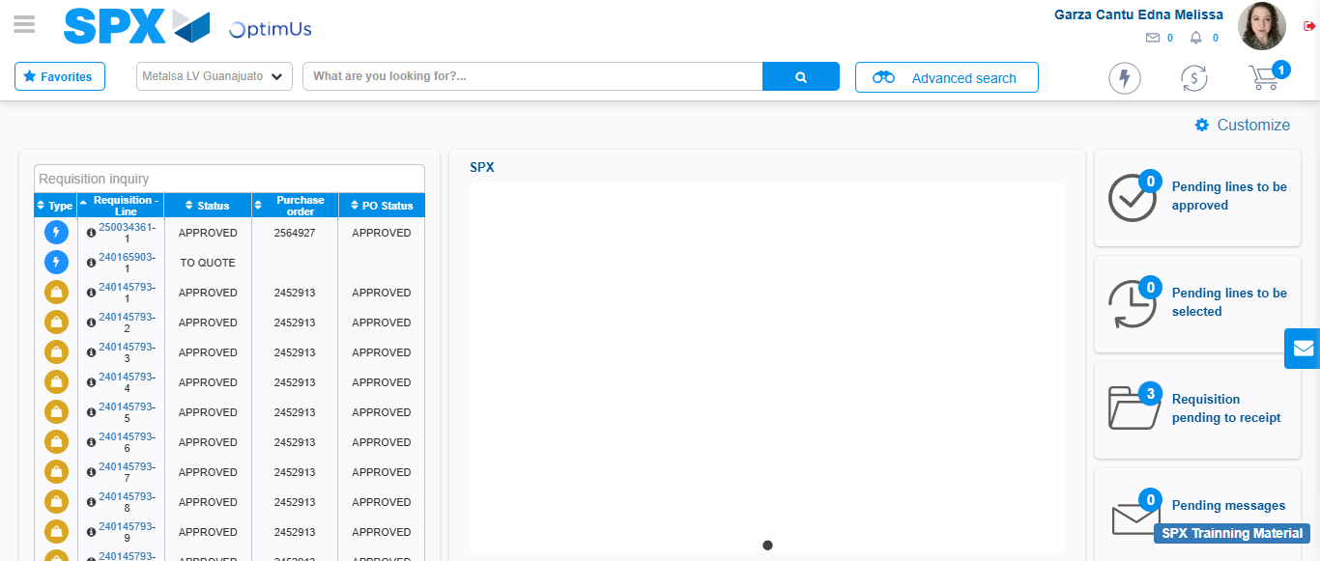Image file-name: QC_Testing-tc003_SPX_Dev5_Validar_Funcionalidad_Botones_Add_Remove_Administrador_Roles_Menu-nov. 20 2025, 01 55 10 p. m.

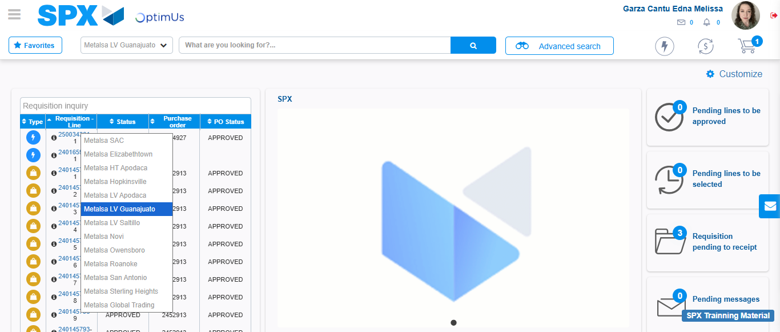Image file-name: QC_Testing-tc004_SPX_Dev5_Validacion_Filtro_Campo_MenuName_Administrador_Menu-nov. 20 2025, 01 55 37 p. m.

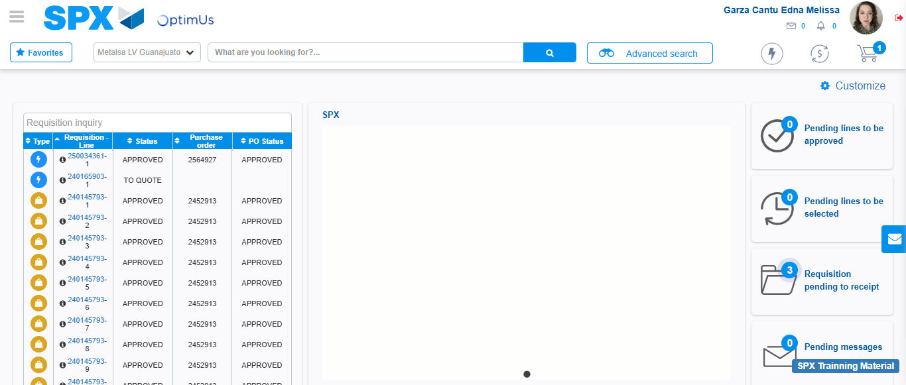Image file-name: QC_Testing-tc005_SPX_Dev5_Validacion_Filtro_Campo_URLPath_Administrador_Menu-nov. 20 2025, 01 56 07 p. m.

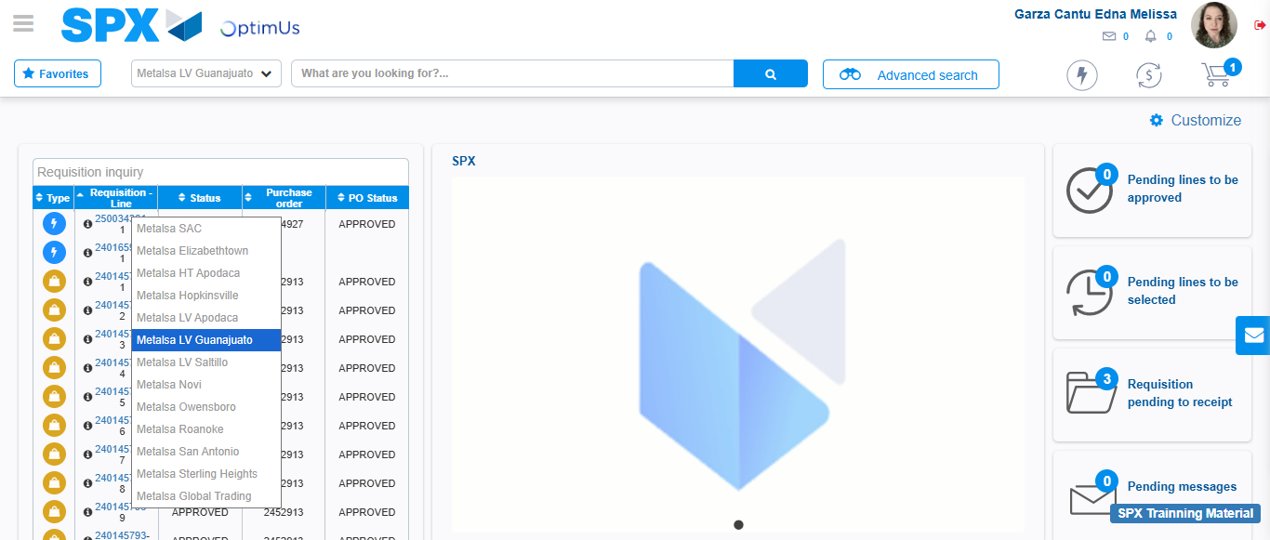Image file-name: QC_Testing-tc006_SPX_Dev5_Validacion_Boton_AddNewMenu_Administrador_Menu-nov. 20 2025, 01 56 29 p. m.

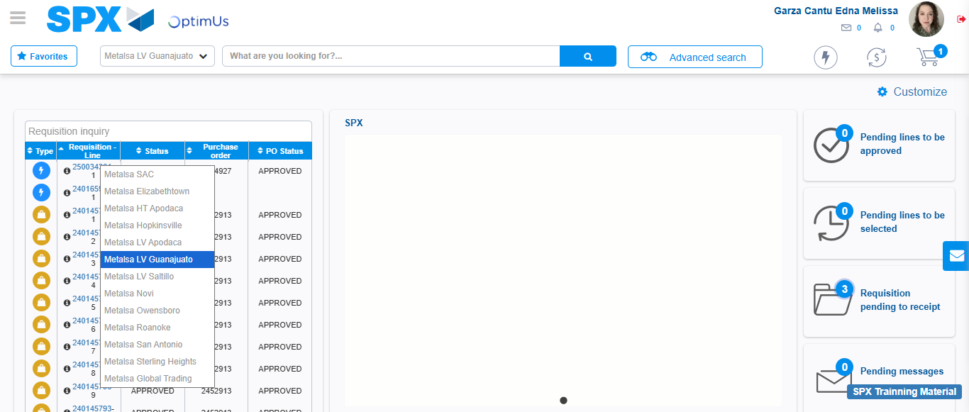Image file-name: QC_Testing-tc007_SPX_Dev5_Validacion_Boton_Edit_Administrador_Menu-nov. 20 2025, 01 56 58 p. m.

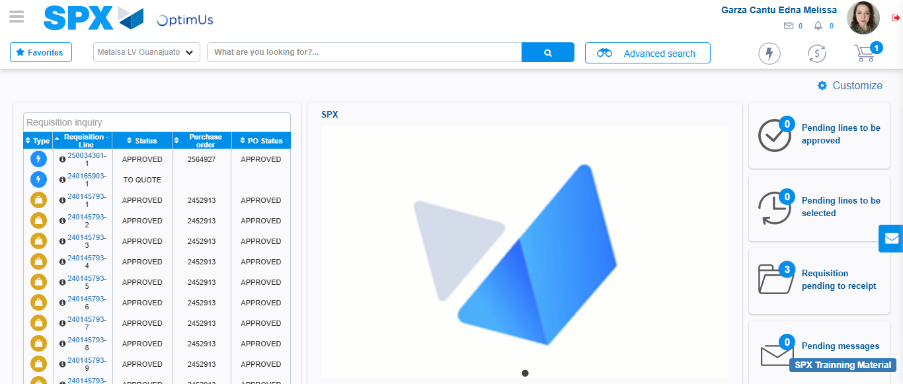Image file-name: QC_Testing-tc008_SPX_Dev5_Validacion_Boton_Remove_Administrador_Menu-nov. 20 2025, 01 57 34 p. m.

Step 2 - Select to UEN and Access to Administrador Roles Menu: UEN Correctly selected and Correct access
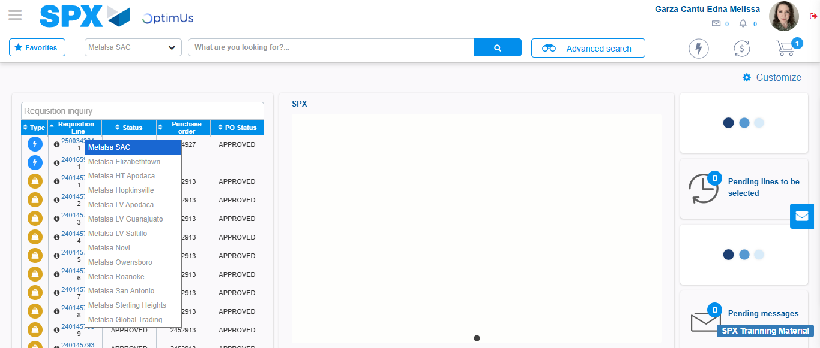Image file-name: QC_Testing-runTestMultipleTimes-nov. 20 2025, 01 53 45 p. m.

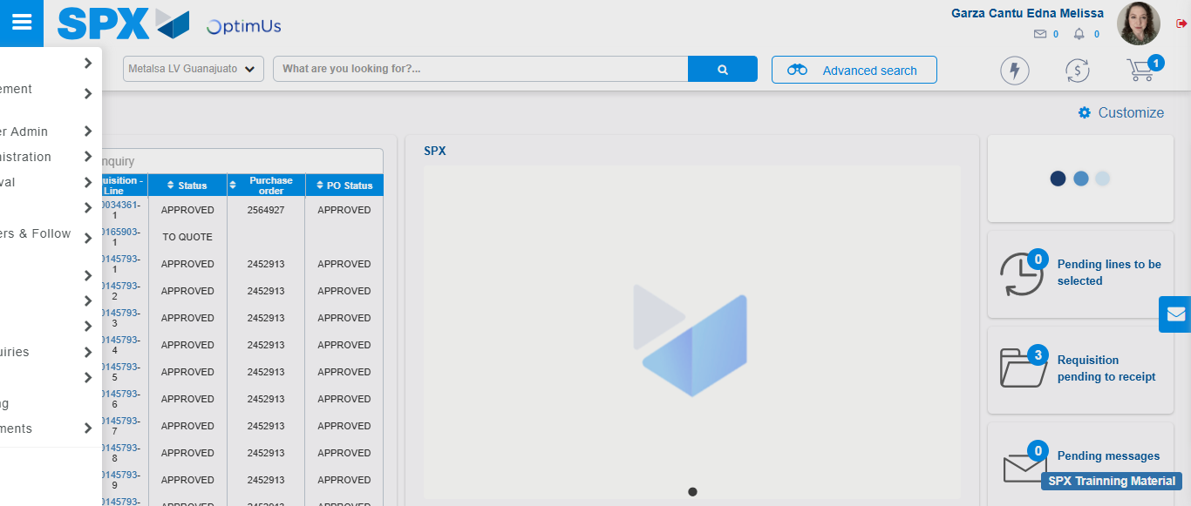Image file-name: QC_Testing-runTestMultipleTimes-nov. 20 2025, 01 53 46 p. m.

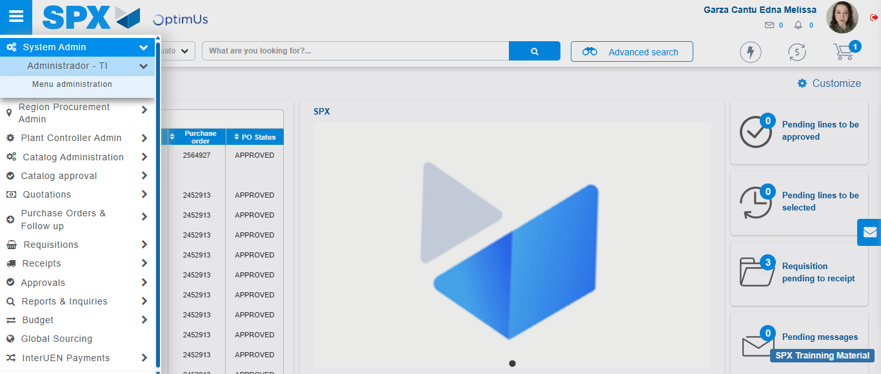Image file-name: QC_Testing-runTestMultipleTimes-nov. 20 2025, 01 53 47 p. m.

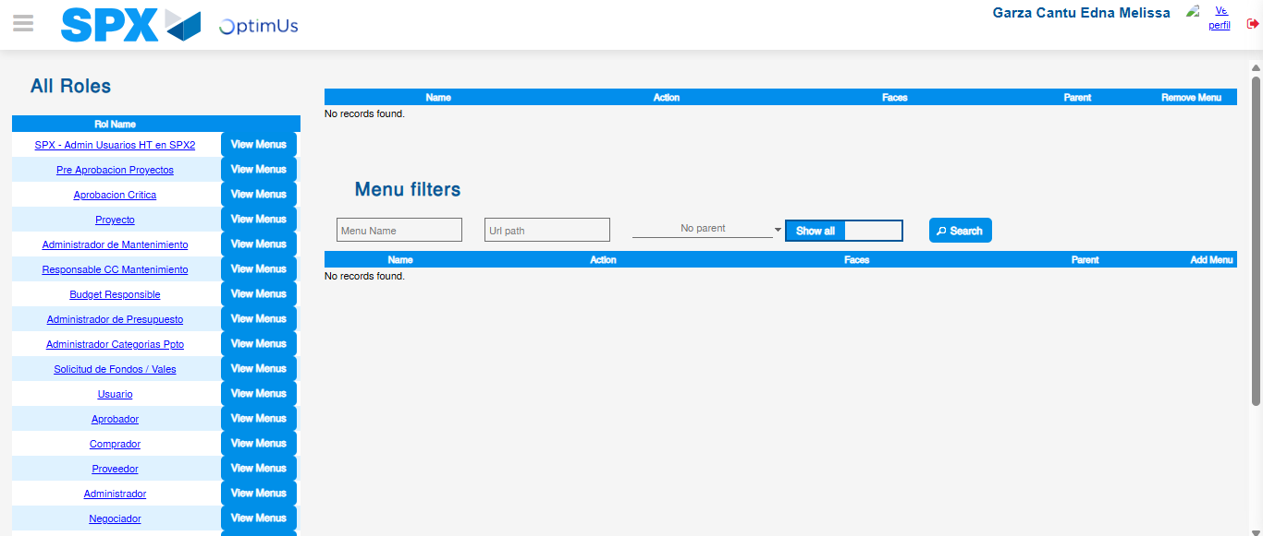Image file-name: QC_Testing-runTestMultipleTimes-nov. 20 2025, 01 53 51 p. m.

Image file-name: QC_Testing-tc001_SPX_Dev5_Validar_Filtro_Campo_MenuName_Administrador_Roles_Menu-nov. 20 2025, 01 54 19 p. m.

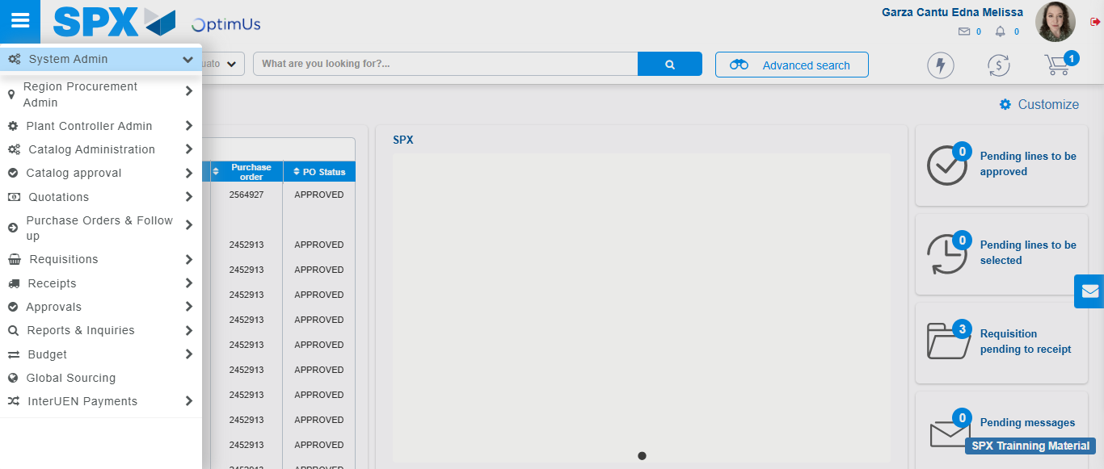Image file-name: QC_Testing-tc001_SPX_Dev5_Validar_Filtro_Campo_MenuName_Administrador_Roles_Menu-nov. 20 2025, 01 54 20 p. m.

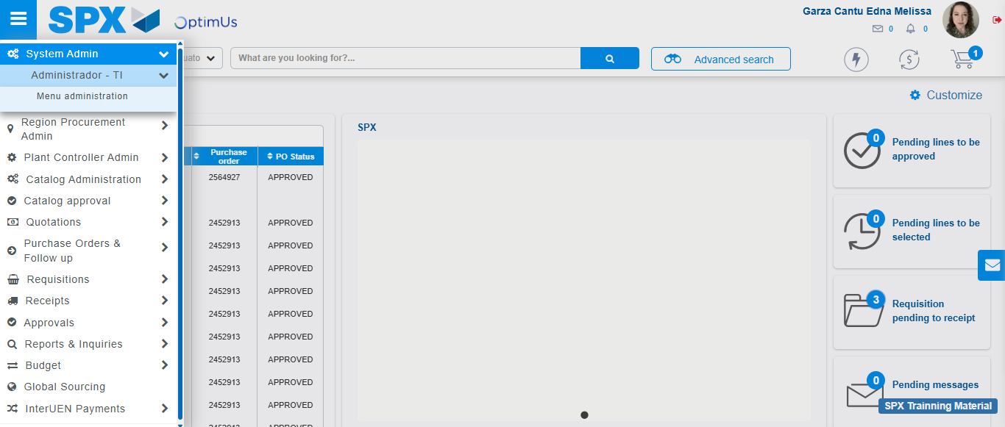Image file-name: QC_Testing-tc001_SPX_Dev5_Validar_Filtro_Campo_MenuName_Administrador_Roles_Menu-nov. 20 2025, 01 54 21 p. m.

Image file-name: QC_Testing-tc001_SPX_Dev5_Validar_Filtro_Campo_MenuName_Administrador_Roles_Menu-nov. 20 2025, 01 54 23 p. m.

Image file-name: QC_Testing-tc002_SPX_Dev5_Validar_Filtro_Campo_URLPath_Administrador_Roles_Menu-nov. 20 2025, 01 54 42 p. m.

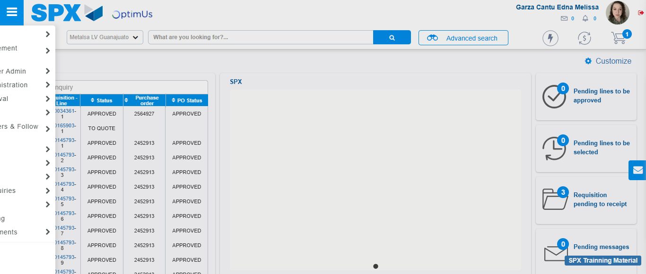Image file-name: QC_Testing-tc002_SPX_Dev5_Validar_Filtro_Campo_URLPath_Administrador_Roles_Menu-nov. 20 2025, 01 54 43 p. m.

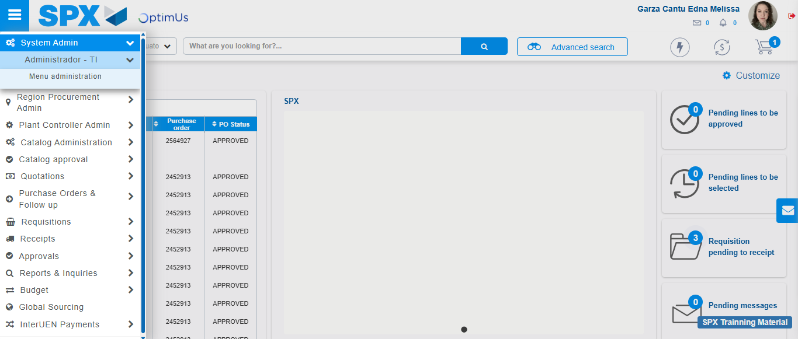Image file-name: QC_Testing-tc002_SPX_Dev5_Validar_Filtro_Campo_URLPath_Administrador_Roles_Menu-nov. 20 2025, 01 54 44 p. m.

Image file-name: QC_Testing-tc002_SPX_Dev5_Validar_Filtro_Campo_URLPath_Administrador_Roles_Menu-nov. 20 2025, 01 54 47 p. m.

Image file-name: QC_Testing-tc003_SPX_Dev5_Validar_Funcionalidad_Botones_Add_Remove_Administrador_Roles_Menu-nov. 20 2025, 01 55 10 p. m.

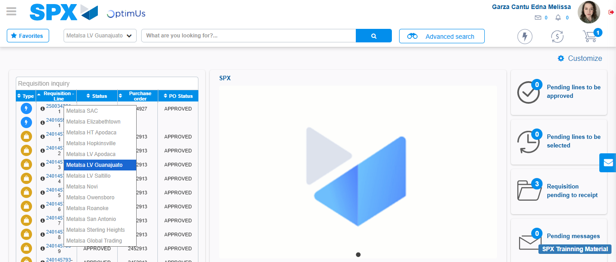Image file-name: QC_Testing-tc003_SPX_Dev5_Validar_Funcionalidad_Botones_Add_Remove_Administrador_Roles_Menu-nov. 20 2025, 01 55 11 p. m.

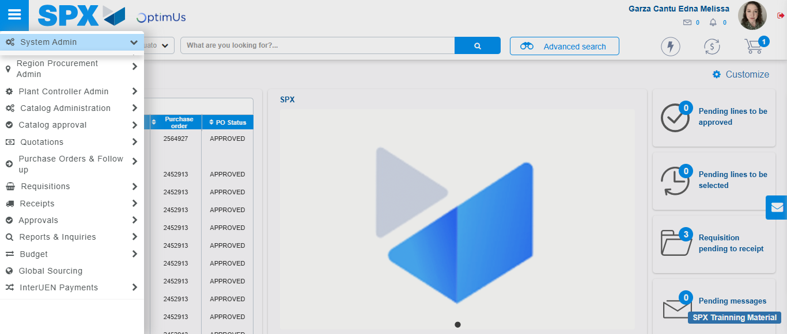Image file-name: QC_Testing-tc003_SPX_Dev5_Validar_Funcionalidad_Botones_Add_Remove_Administrador_Roles_Menu-nov. 20 2025, 01 55 12 p. m.

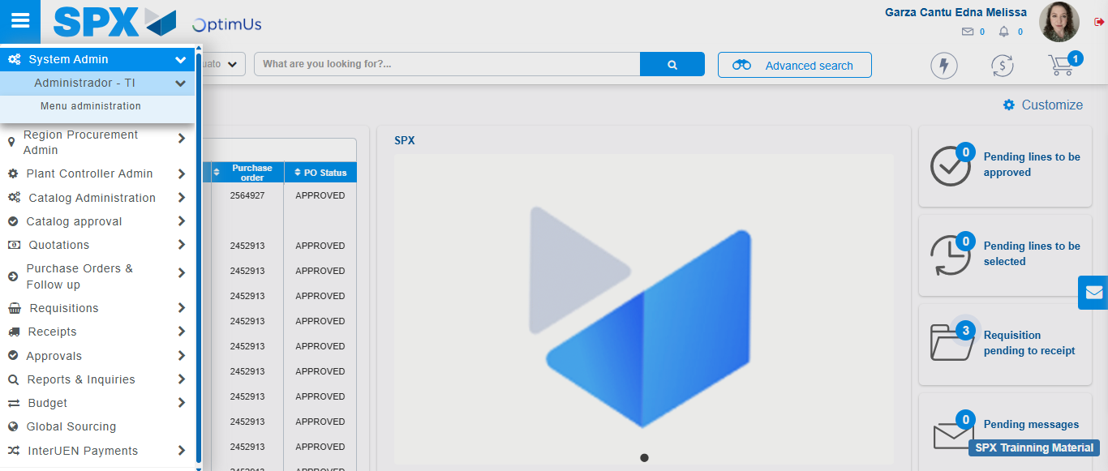Image file-name: QC_Testing-tc003_SPX_Dev5_Validar_Funcionalidad_Botones_Add_Remove_Administrador_Roles_Menu-nov. 20 2025, 01 55 13 p. m.

Image file-name: QC_Testing-tc003_SPX_Dev5_Validar_Funcionalidad_Botones_Add_Remove_Administrador_Roles_Menu-nov. 20 2025, 01 55 14 p. m.

Image file-name: QC_Testing-tc004_SPX_Dev5_Validacion_Filtro_Campo_MenuName_Administrador_Menu-nov. 20 2025, 01 55 37 p. m.

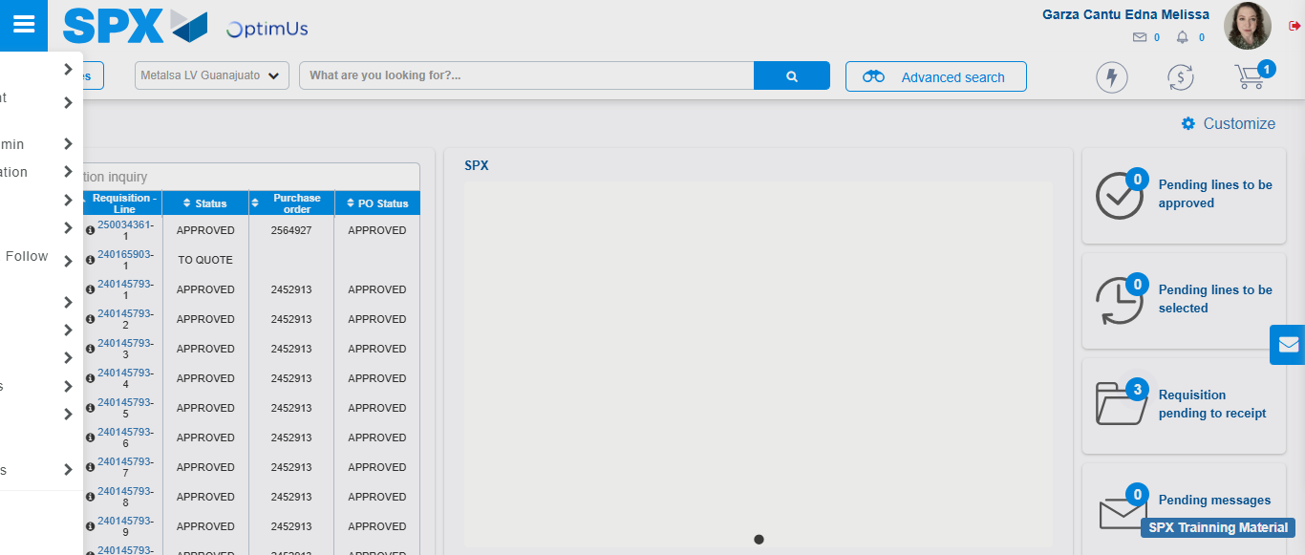Image file-name: QC_Testing-tc004_SPX_Dev5_Validacion_Filtro_Campo_MenuName_Administrador_Menu-nov. 20 2025, 01 55 38 p. m.

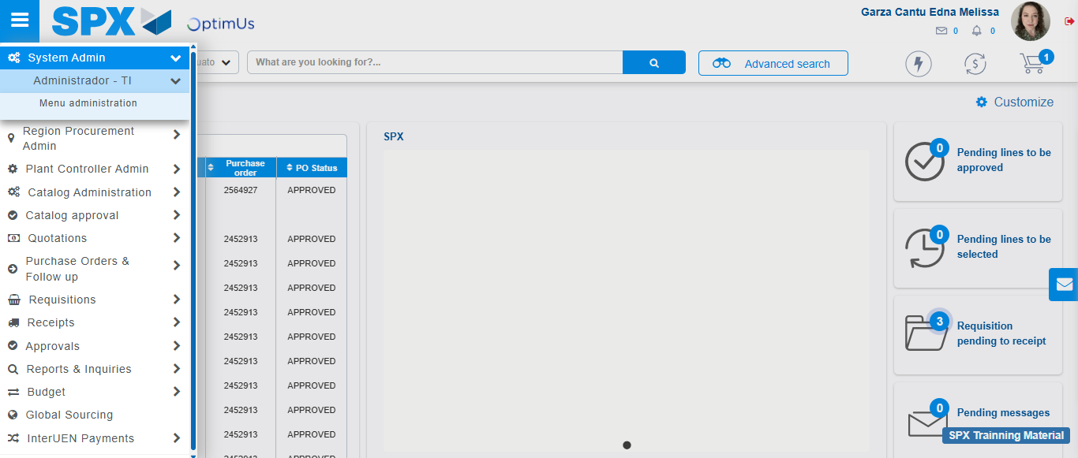Image file-name: QC_Testing-tc004_SPX_Dev5_Validacion_Filtro_Campo_MenuName_Administrador_Menu-nov. 20 2025, 01 55 39 p. m.

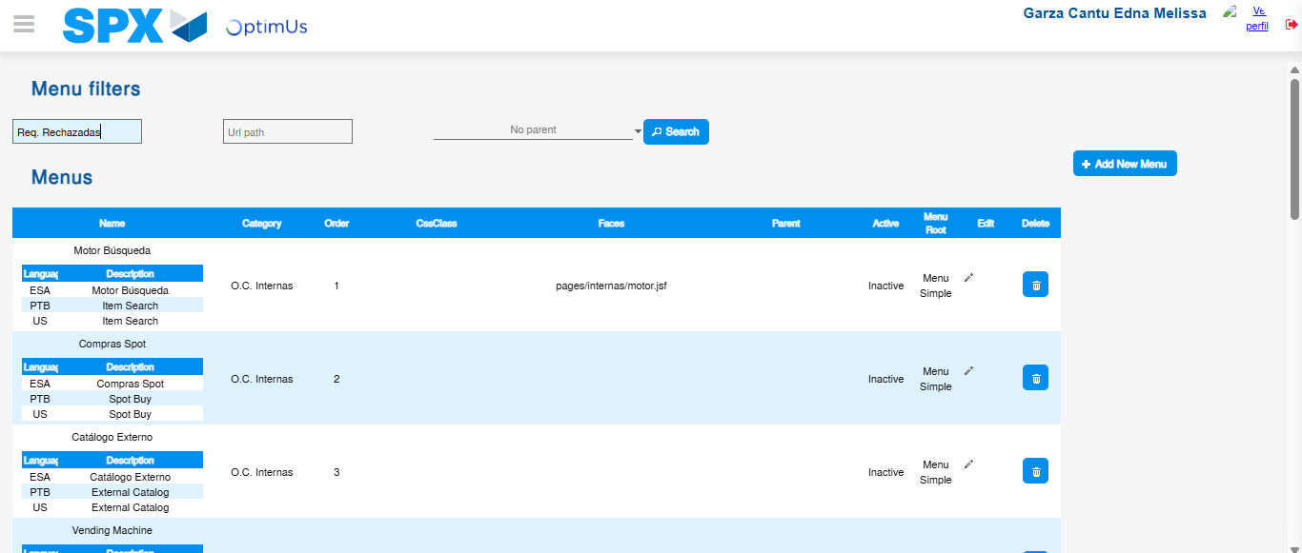Image file-name: QC_Testing-tc004_SPX_Dev5_Validacion_Filtro_Campo_MenuName_Administrador_Menu-nov. 20 2025, 01 55 45 p. m.

Image file-name: QC_Testing-tc005_SPX_Dev5_Validacion_Filtro_Campo_URLPath_Administrador_Menu-nov. 20 2025, 01 56 07 p. m.

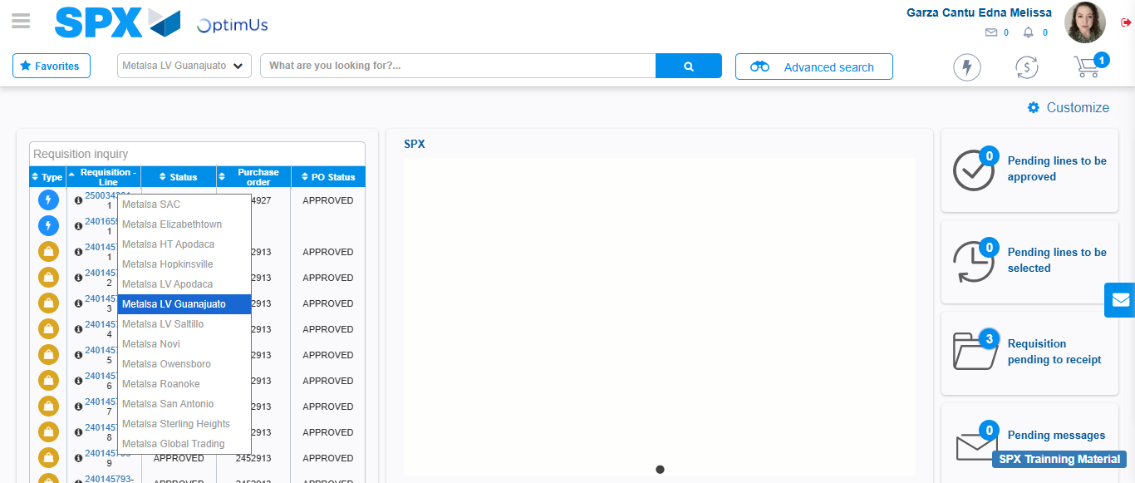Image file-name: QC_Testing-tc005_SPX_Dev5_Validacion_Filtro_Campo_URLPath_Administrador_Menu-nov. 20 2025, 01 56 08 p. m.

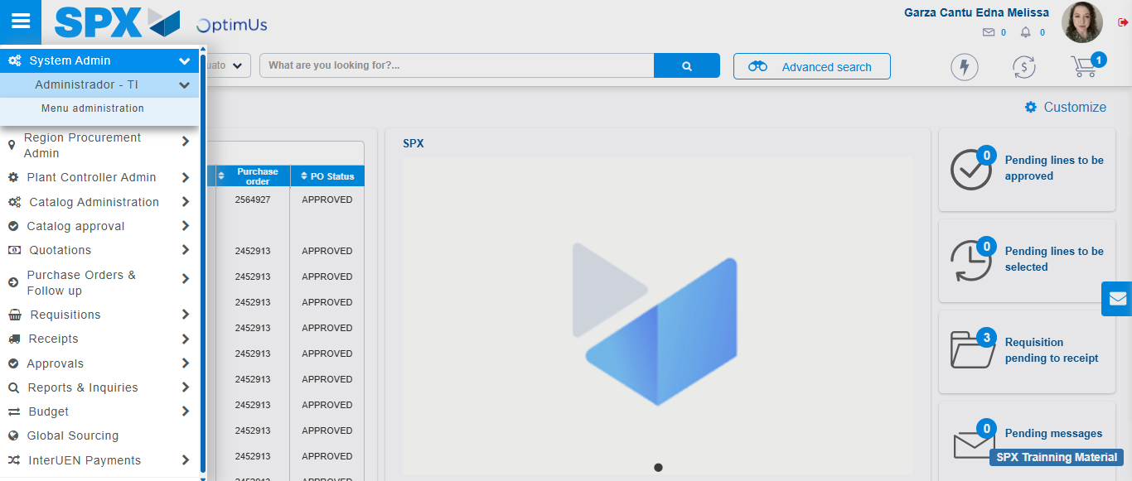Image file-name: QC_Testing-tc005_SPX_Dev5_Validacion_Filtro_Campo_URLPath_Administrador_Menu-nov. 20 2025, 01 56 09 p. m.

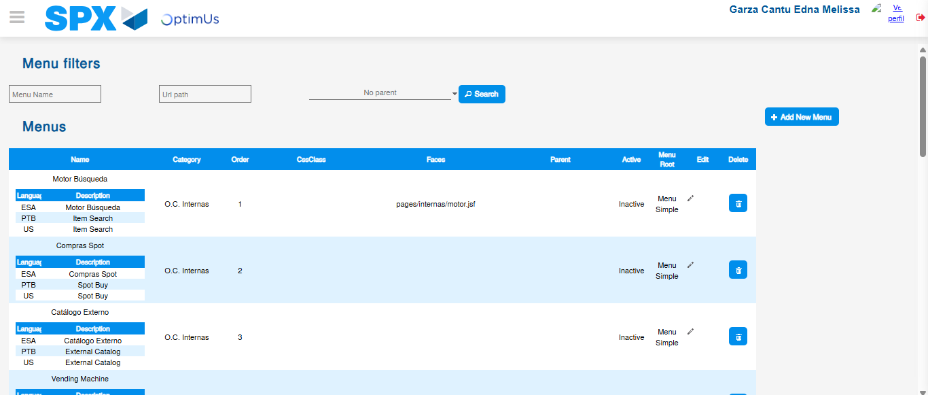Image file-name: QC_Testing-tc005_SPX_Dev5_Validacion_Filtro_Campo_URLPath_Administrador_Menu-nov. 20 2025, 01 56 12 p. m.

Image file-name: QC_Testing-tc006_SPX_Dev5_Validacion_Boton_AddNewMenu_Administrador_Menu-nov. 20 2025, 01 56 29 p. m.

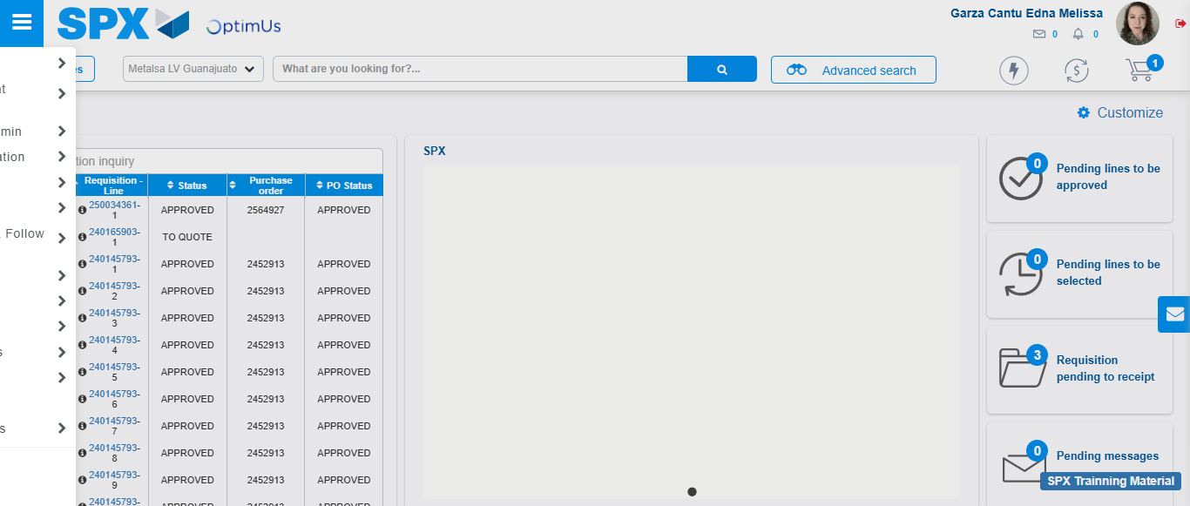Image file-name: QC_Testing-tc006_SPX_Dev5_Validacion_Boton_AddNewMenu_Administrador_Menu-nov. 20 2025, 01 56 30 p. m.

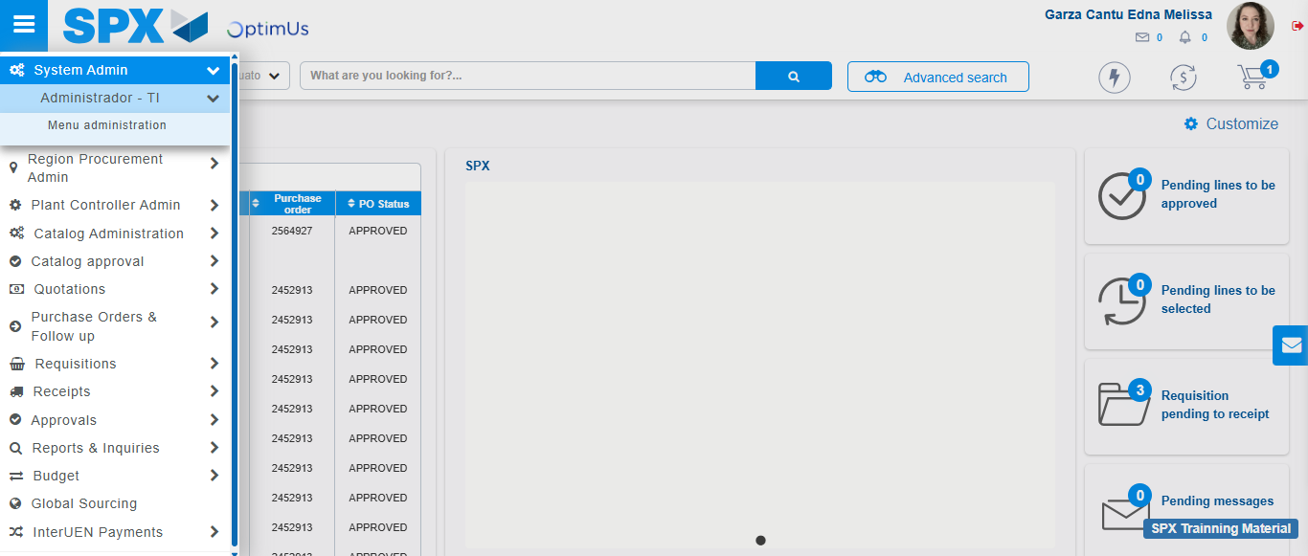Image file-name: QC_Testing-tc006_SPX_Dev5_Validacion_Boton_AddNewMenu_Administrador_Menu-nov. 20 2025, 01 56 31 p. m.

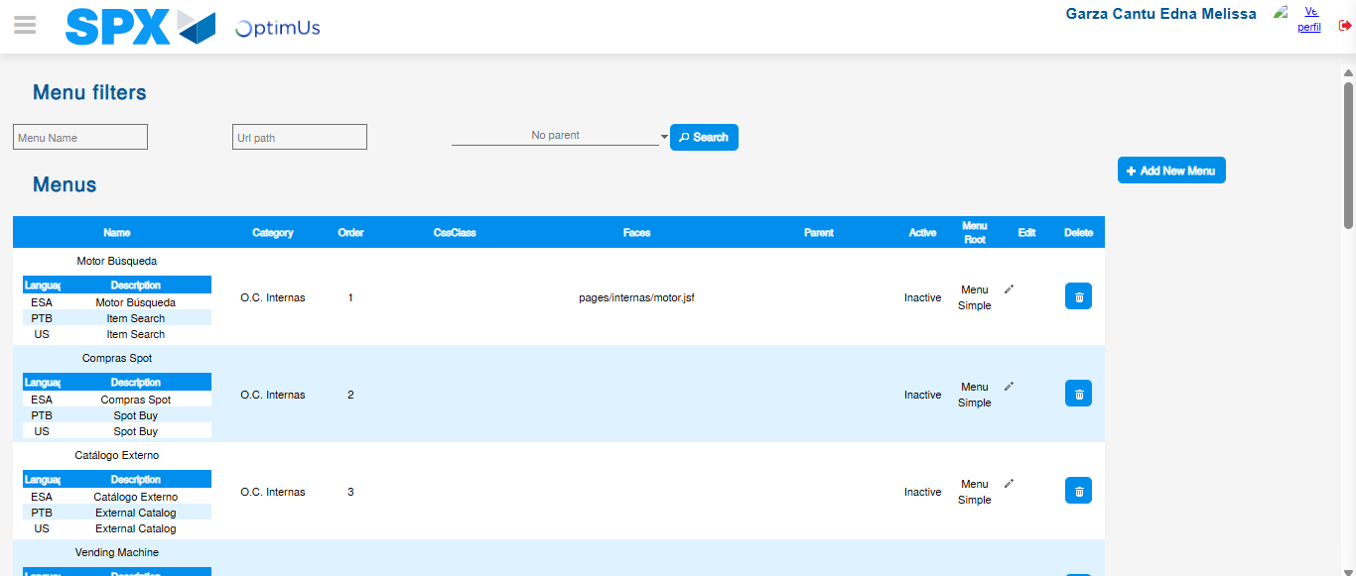Image file-name: QC_Testing-tc006_SPX_Dev5_Validacion_Boton_AddNewMenu_Administrador_Menu-nov. 20 2025, 01 56 35 p. m.

Image file-name: QC_Testing-tc007_SPX_Dev5_Validacion_Boton_Edit_Administrador_Menu-nov. 20 2025, 01 56 58 p. m.

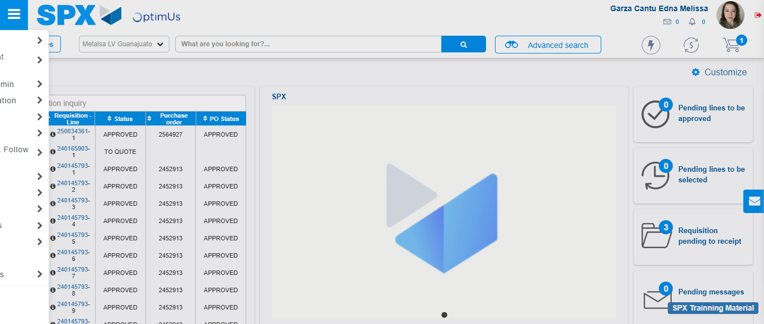Image file-name: QC_Testing-tc007_SPX_Dev5_Validacion_Boton_Edit_Administrador_Menu-nov. 20 2025, 01 56 59 p. m.

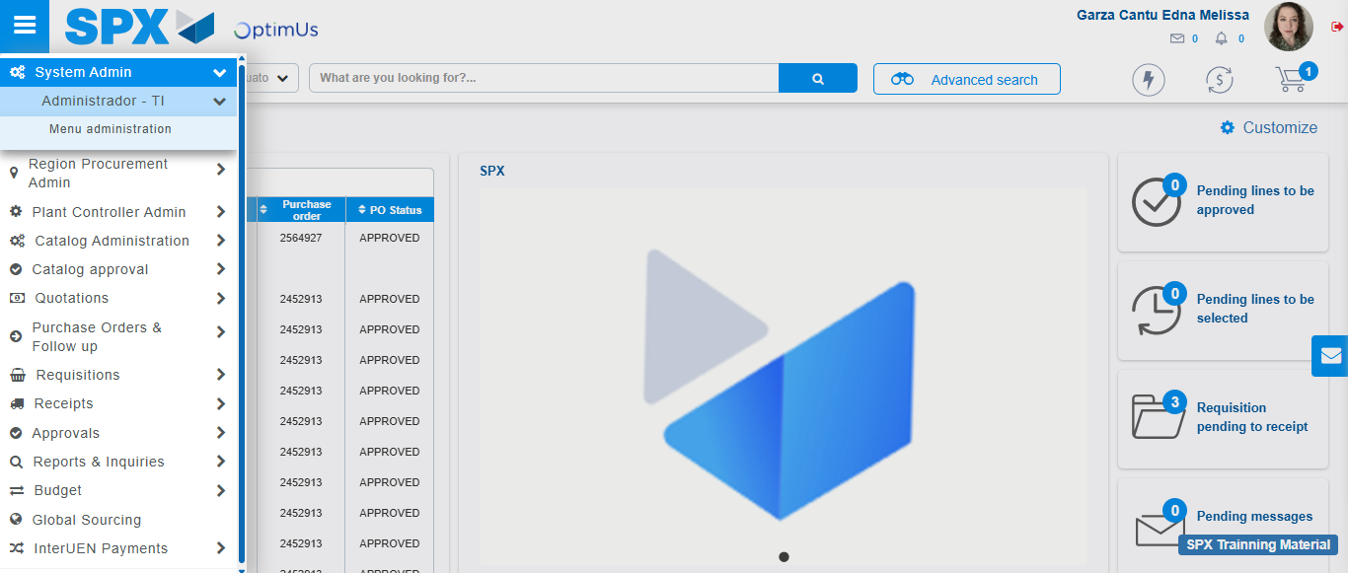Image file-name: QC_Testing-tc007_SPX_Dev5_Validacion_Boton_Edit_Administrador_Menu-nov. 20 2025, 01 57 00 p. m.

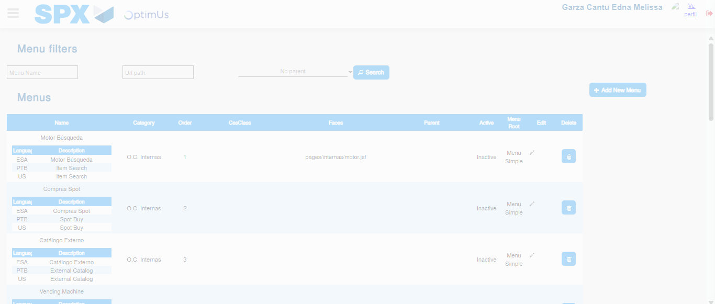Image file-name: QC_Testing-tc007_SPX_Dev5_Validacion_Boton_Edit_Administrador_Menu-nov. 20 2025, 01 57 03 p. m.

Image file-name: QC_Testing-tc008_SPX_Dev5_Validacion_Boton_Remove_Administrador_Menu-nov. 20 2025, 01 57 34 p. m.

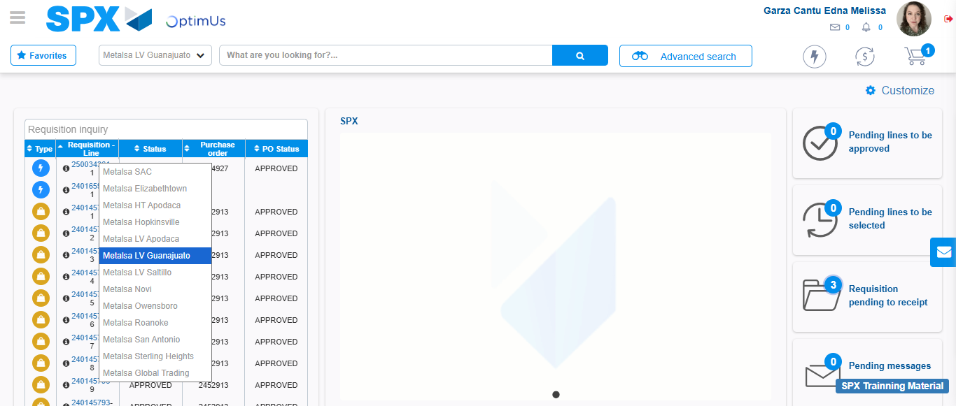Image file-name: QC_Testing-tc008_SPX_Dev5_Validacion_Boton_Remove_Administrador_Menu-nov. 20 2025, 01 57 35 p. m.

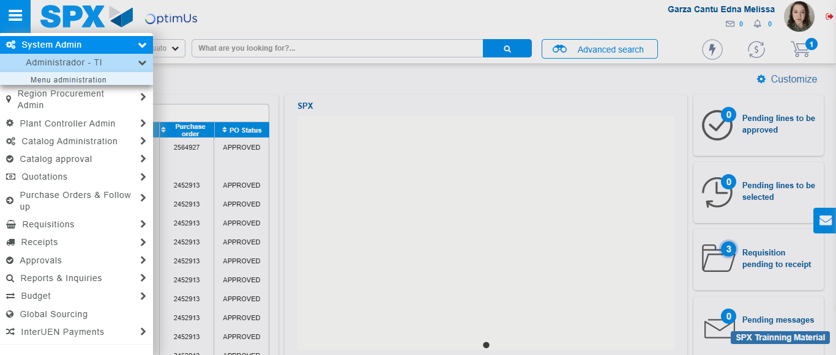Image file-name: QC_Testing-tc008_SPX_Dev5_Validacion_Boton_Remove_Administrador_Menu-nov. 20 2025, 01 57 36 p. m.

Image file-name: QC_Testing-tc008_SPX_Dev5_Validacion_Boton_Remove_Administrador_Menu-nov. 20 2025, 01 57 41 p. m.

Step 3 - Delete record: Record successfully deleted
Image file-name: QC_Testing-tc004_SPX_Dev5_Validacion_Filtro_Campo_MenuName_Administrador_Menu-nov. 20 2025, 01 55 45 p. m.

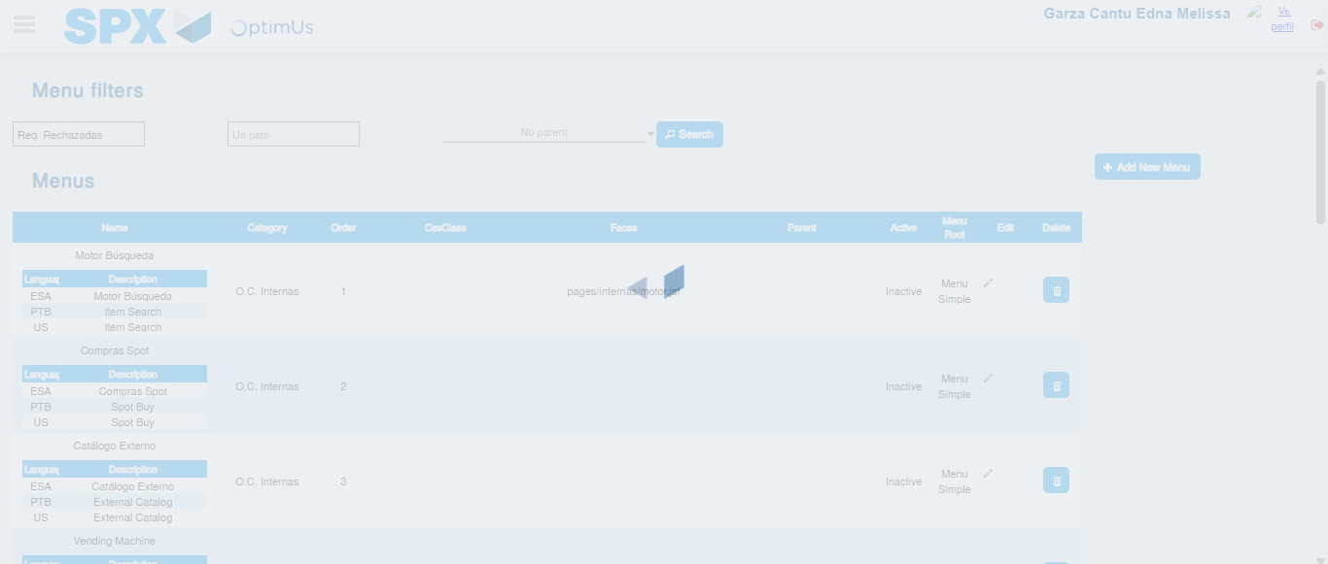Image file-name: QC_Testing-tc004_SPX_Dev5_Validacion_Filtro_Campo_MenuName_Administrador_Menu-nov. 20 2025, 01 55 46 p. m.

Image file-name: QC_Testing-tc005_SPX_Dev5_Validacion_Filtro_Campo_URLPath_Administrador_Menu-nov. 20 2025, 01 56 12 p. m.

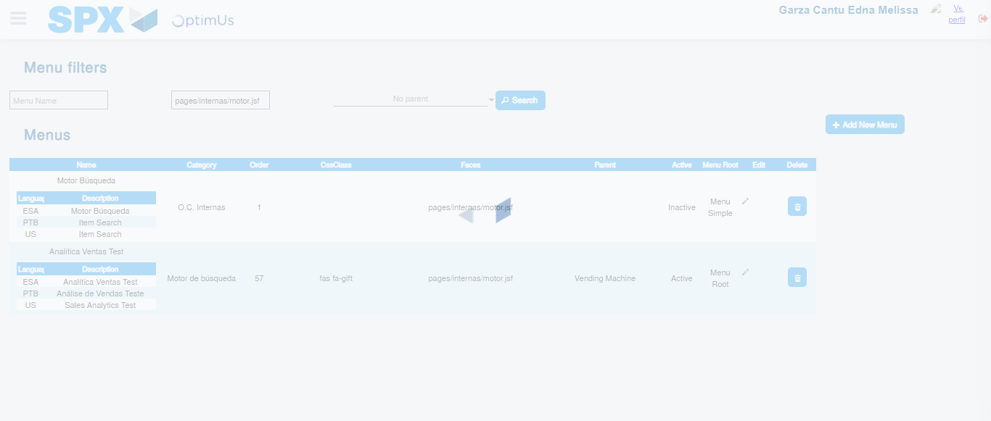Image file-name: QC_Testing-tc005_SPX_Dev5_Validacion_Filtro_Campo_URLPath_Administrador_Menu-nov. 20 2025, 01 56 13 p. m.

Image file-name: QC_Testing-tc006_SPX_Dev5_Validacion_Boton_AddNewMenu_Administrador_Menu-nov. 20 2025, 01 56 35 p. m.

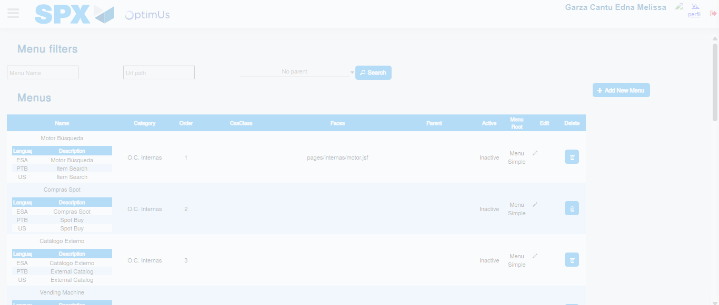Image file-name: QC_Testing-tc006_SPX_Dev5_Validacion_Boton_AddNewMenu_Administrador_Menu-nov. 20 2025, 01 56 36 p. m.

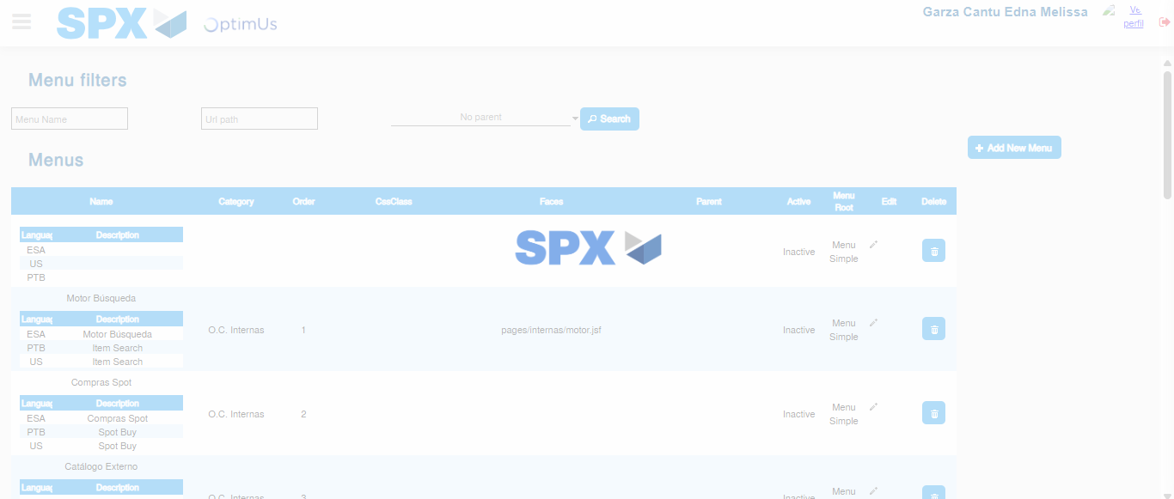Image file-name: QC_Testing-tc006_SPX_Dev5_Validacion_Boton_AddNewMenu_Administrador_Menu-nov. 20 2025, 01 56 39 p. m.

Image file-name: QC_Testing-tc007_SPX_Dev5_Validacion_Boton_Edit_Administrador_Menu-nov. 20 2025, 01 57 03 p. m.

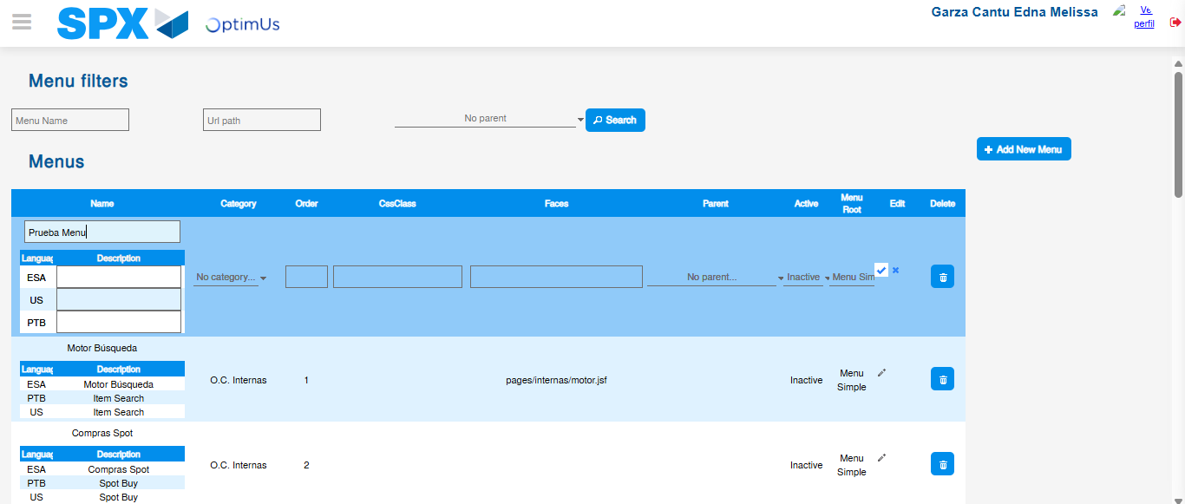Image file-name: QC_Testing-tc007_SPX_Dev5_Validacion_Boton_Edit_Administrador_Menu-nov. 20 2025, 01 57 07 p. m.

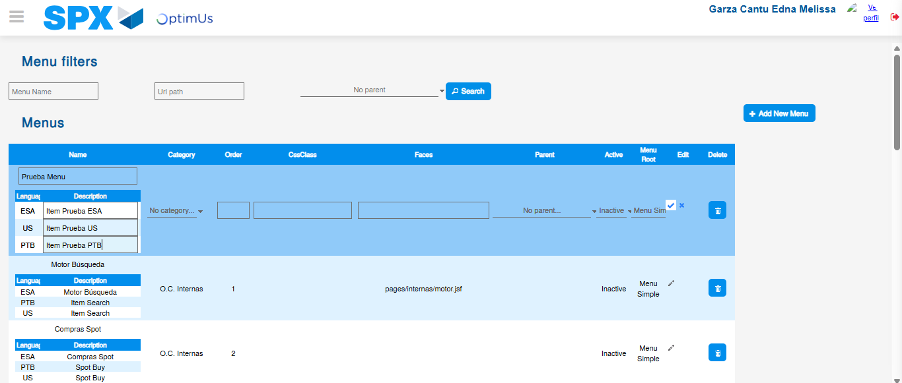Image file-name: QC_Testing-tc007_SPX_Dev5_Validacion_Boton_Edit_Administrador_Menu-nov. 20 2025, 01 57 08 p. m.

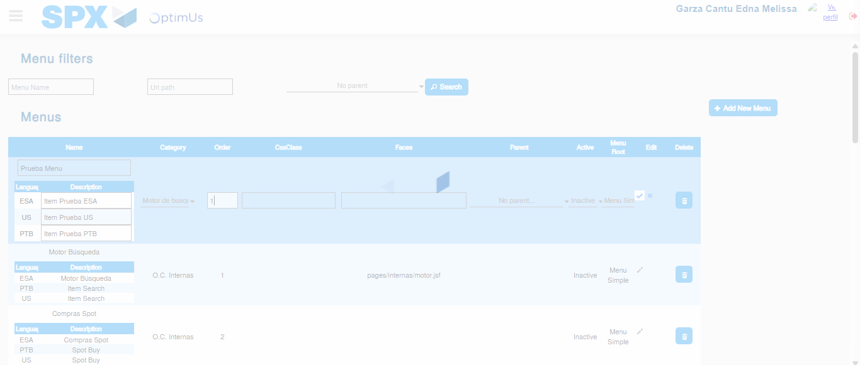Image file-name: QC_Testing-tc007_SPX_Dev5_Validacion_Boton_Edit_Administrador_Menu-nov. 20 2025, 01 57 09 p. m.

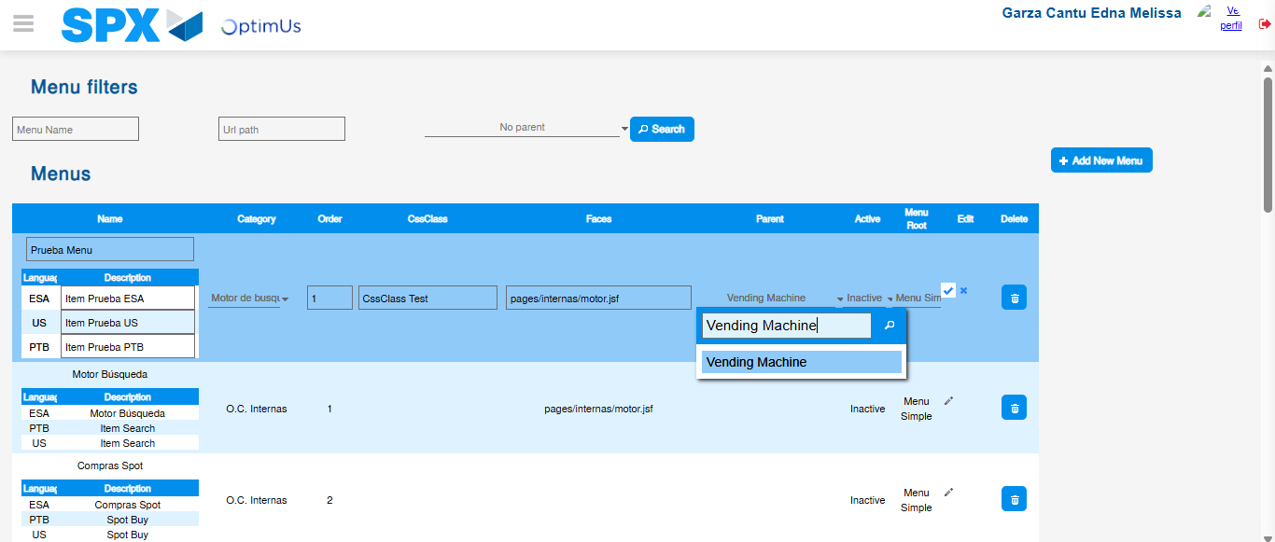Image file-name: QC_Testing-tc007_SPX_Dev5_Validacion_Boton_Edit_Administrador_Menu-nov. 20 2025, 01 57 10 p. m.

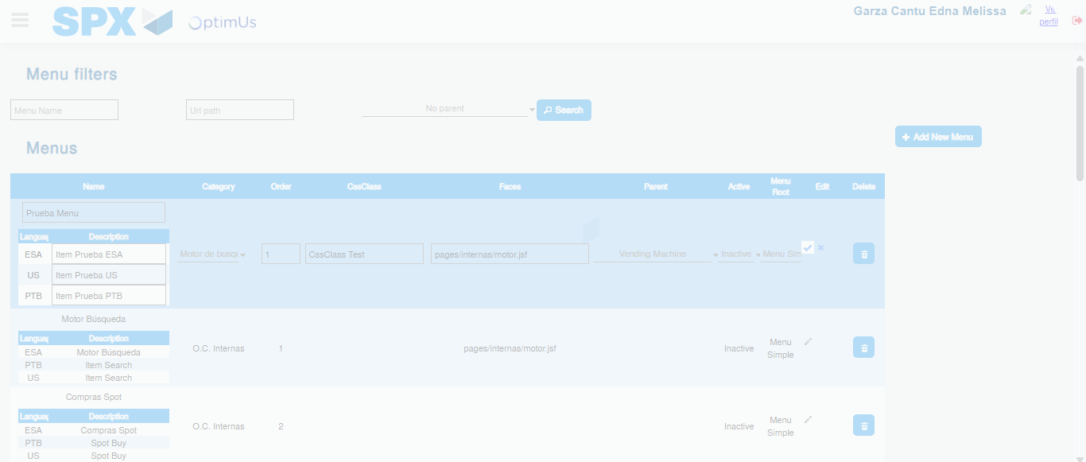Image file-name: QC_Testing-tc007_SPX_Dev5_Validacion_Boton_Edit_Administrador_Menu-nov. 20 2025, 01 57 11 p. m.

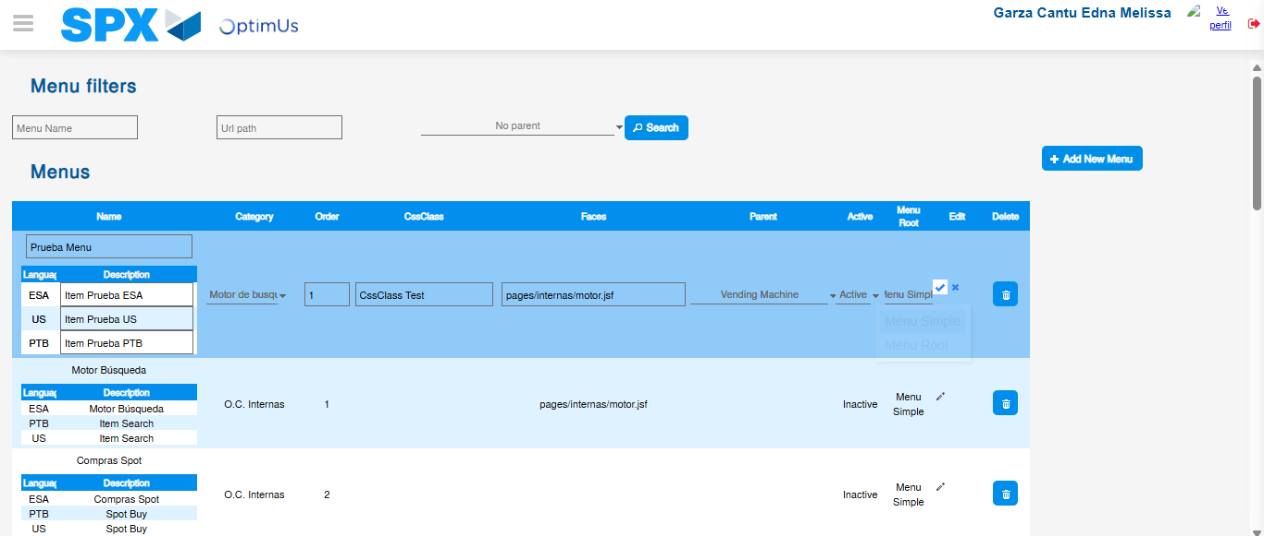Image file-name: QC_Testing-tc007_SPX_Dev5_Validacion_Boton_Edit_Administrador_Menu-nov. 20 2025, 01 57 12 p. m.

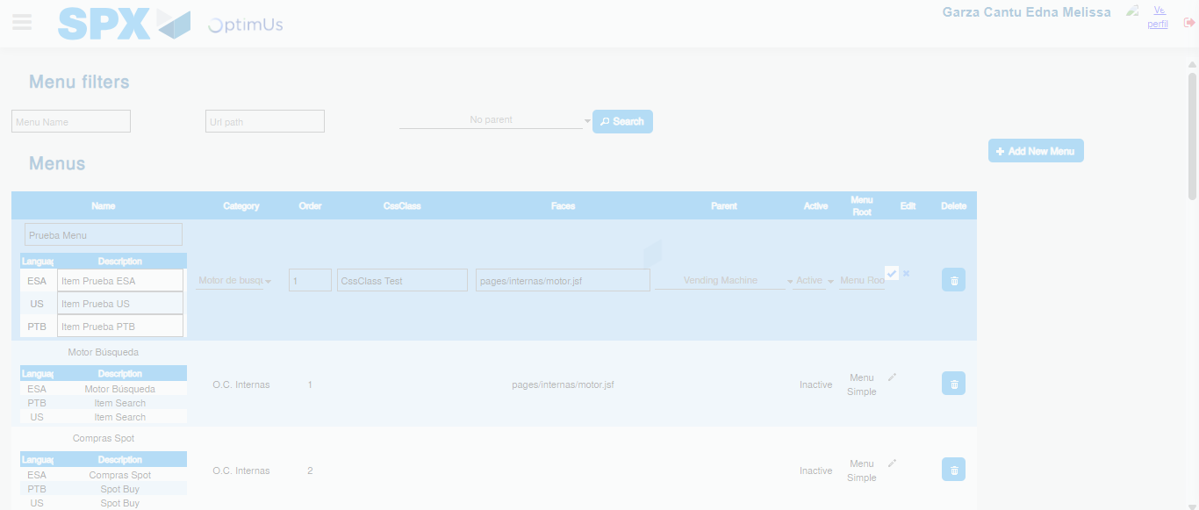Image file-name: QC_Testing-tc007_SPX_Dev5_Validacion_Boton_Edit_Administrador_Menu-nov. 20 2025, 01 57 13 p. m.

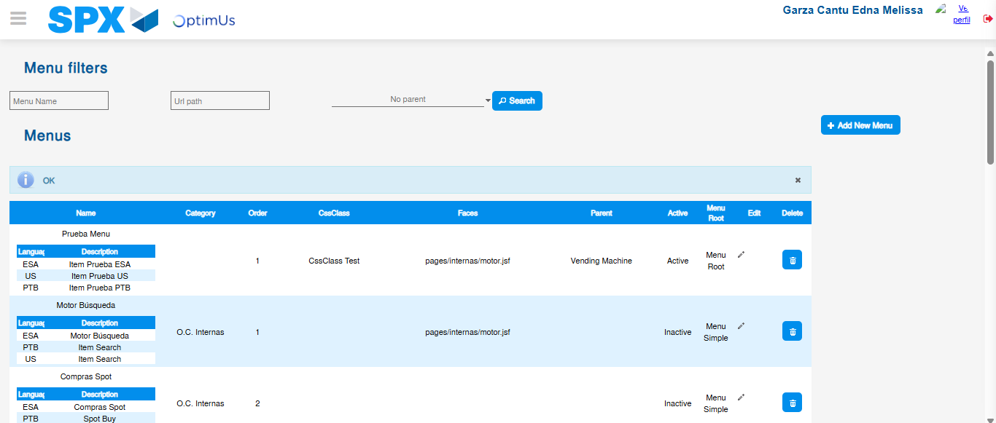Image file-name: QC_Testing-tc007_SPX_Dev5_Validacion_Boton_Edit_Administrador_Menu-nov. 20 2025, 01 57 16 p. m.

Image file-name: QC_Testing-tc008_SPX_Dev5_Validacion_Boton_Remove_Administrador_Menu-nov. 20 2025, 01 57 41 p. m.

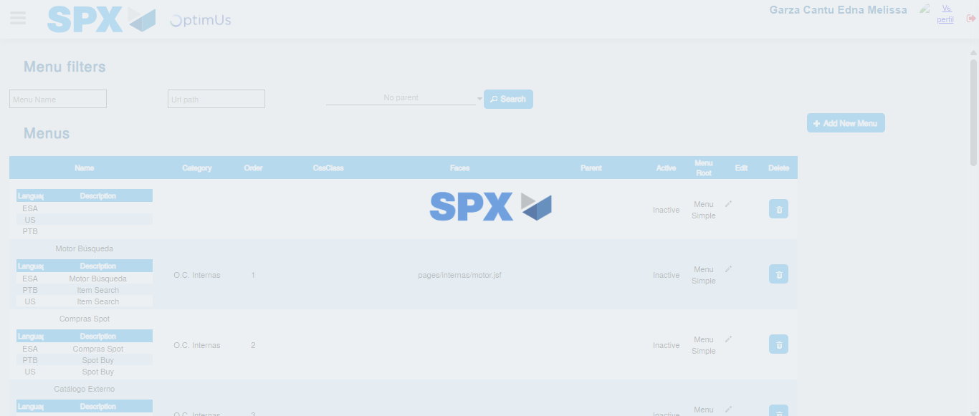Image file-name: QC_Testing-tc008_SPX_Dev5_Validacion_Boton_Remove_Administrador_Menu-nov. 20 2025, 01 57 44 p. m.

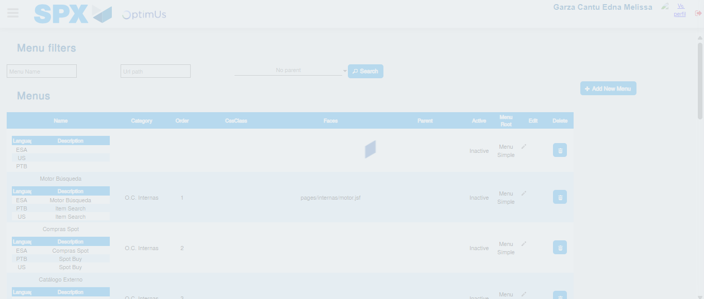Image file-name: QC_Testing-tc008_SPX_Dev5_Validacion_Boton_Remove_Administrador_Menu-nov. 20 2025, 01 57 45 p. m.

